**Muhammad Umar Ahmadzai**

**03/24/2018**

**ClockType**

**Problem Statement:**

The program has values assigned and will give the time as result.

**Input/Output Description:**

**Following are going to output types of filling:**

We only have two outputs which outputs the time (one in the class and one in result:

cout << "The time is: " << h << ":" << m << ":" << s << "." << endl;

cout << endl <<endl << "This is the results section: " << endl << endl << "The time is: " << h << ":" << m << ":" << s << "." << endl;

Basically, we are creating clock class, and we have defined set time, get time, increment hours, increment minutes, increment seconds and print results. In the end we output the time. Set time and get time will be given specific values to display for time, and increment seconds, hours, and minutes will increment by a number those value. Print time will print the final result.

**Program Listing:**

#include <iostream>

using namespace std;

class clocktype

{

private:

int h;

int m;

int s;

public:

clocktype();

void settime (int h,int m, int s);

void gettime(int&h, int&m, int&s);

void incrementhours();

void incrementminutes();

void incrementseconds();

void printtime();

};

clocktype::clocktype()

{

h=1;

m=2;

s=3;

}

void clocktype::settime(int h, int m, int s)

{

int hours, minutes, seconds;

h=hours;

m=minutes;

s=seconds;

}

void clocktype::gettime (int& h,int&m, int&s)

{

int hours, minutes, seconds;

hours=h;

minutes=m;

seconds=s;

}

void clocktype::incrementhours()

{

h++;

}

void clocktype::incrementminutes ()

{

m++;

}

void clocktype::incrementseconds()

{

s++;

}

void clocktype::printtime()

{

cout << "The time is: " << h << ":" << m << ":" << s << "." << endl;

}

int main()

{

int h=2,m=3,s=4;

clocktype c;

c.settime(h,m,s);

c.gettime(h,m,s);

c.incrementhours();

c.incrementminutes();

c.incrementseconds();

c.printtime();

cout << endl <<endl << "This is the results section: " << endl << endl << "The time is: " << h << ":" << m << ":" << s << "." << endl;

}

**Sample test run of the program:**

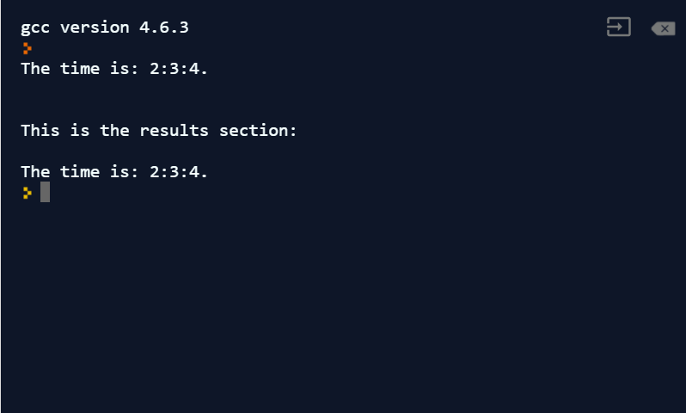

**Observation and Error Handling and general comments:**

Did not faced any errors.

**Conclusion:**

In conclusion, it will output the time, but the code is made based on classes.